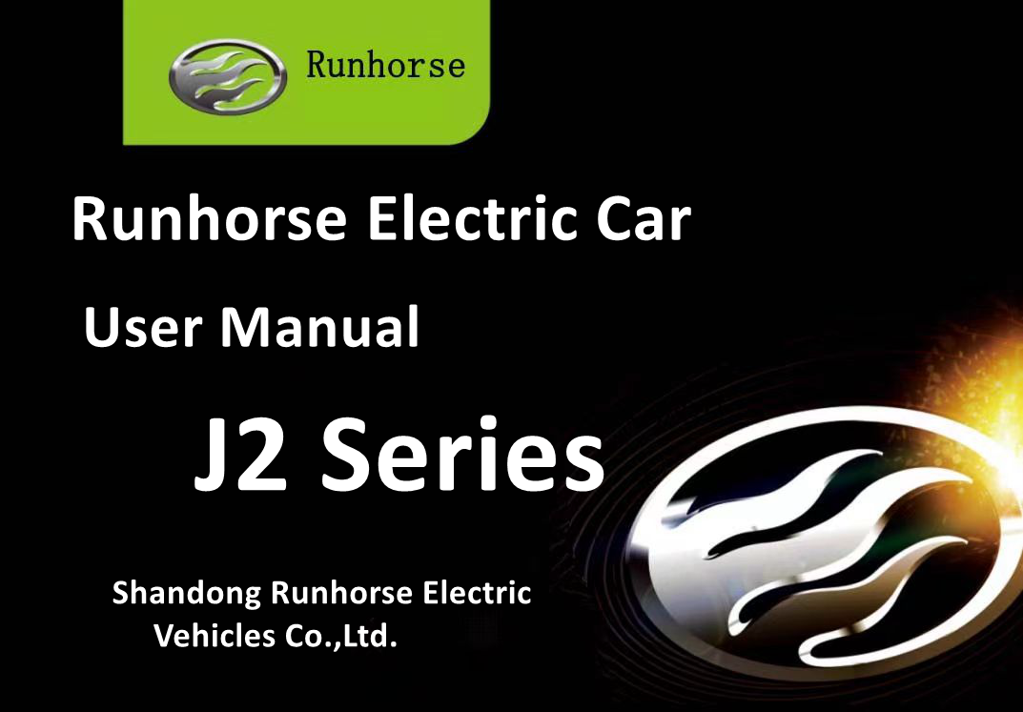

Forward
Dear Valued Client：
Thank you for choosing the "RUNHORSE" brand electric vehicle products produced by Shandong Runhorse electric vehicles Co.,Ltd. .
"RUNHORSE" brand electric three wheel electric vehicle is fashionable, advanced technology, sophisticated technology, excellent performance, safe and comfortable, energy-saving and economical. It is an excellent product integrating excellent design and excellent quality.
In order to help you familiarize yourself with the operation of the vehicle, please read this manual carefully before driving. Please do not use it before you understand the characteristics of the electric motorcycle. If the power supply is damaged or the charging system is out of order, please replace or repair it at the maintenance shop designated by our company.
All the information in this preface is the newest information before delivery. As the company will continue to innovate and improve the products to better meet the needs of users, subsequent changes are subject to change without notice. If you have any questions about the product, you can contact us directly and we will be happy to help you.
RUNHORSE E-cars,Driving the further,we sincerely wish you a happy ride.

Important Tips
The final interpretation of this manual belongs to Shandong Runhorse electric vehicles Co.,Ltd. The company reserves the right to improve the product after printing this manual without prior notice. Some pictures in this book are schematic diagrams, which are for reference only. If they are not completely consistent with the real thing, the actual product shall prevail.
Please place this manual in your car so that you can find it when you need it. Because this book is an important part of the car, please hand it over to the new owner when you resell the car.
This manual only provides basic maintenance instructions. If there is a problem with the vehicle during use, please do not disassemble the vehicle without authorization. Seek professional help. The loss caused by unauthorized removal of the vehicle shall be borne by the user.
When replacing parts and components of vehicles, the qualified parts and components produced by the company's special suppliers shall be used. If the company's parts and components other than the company's special suppliers are used, the company's warranty service will not be enjoyed, and the consequences will be caused by the users themselves.
Please keep this manual and vehicle documentation, vehicle invoice and other vehicle documentation properly to ensure that you enjoy the perfect after-sales service provided by our company.
Note: If you have any doubts during the use of this book, the company and our special service station will be happy to provide you with instructions, and you are welcome to give us your valuable comments.

Shandong Runhorse electric vehicles Co.,Ltd.
Content
Introduction of the whole vehicle 1
Nameplate, vehicle identification code, motor number 1
Vehicle documentation 1
Auxiliary power switch 2
Start switch 2
Combination dashboard 3
Combination dashboard overview（Lead Acid Battery） 3
Combination dashboard overview（Lithium Battery Car） 4
Combination Dashboard 5
Warning light 5
Hazard warning light switch 7
Light combination switch 8
Wiper combination switch 9
Steering wheel/horn switch 10
Air conditioner switch 10
Shift switch 11
Foot pedal 11
Parking brake 12
Exterior mirror 12
Multi-Media 13
3.Radio Search 13
Door lock 14
Glass rise and fall 15
Charging port 15
Seater 16
Safebelt 17
Driving method 18
Driving preparation 18
Running-in instructions 18
Pre-departure check 19
Driving 20
Vehicle start 20
Shift 21
Turn direction 21
Multiple driving 22
Multi-mode driving 23
Braking, stoping and parking 24
Vehicle parking 25
Emergency management 26
Emergency management 27
Charging 28
Charge 29
Maintenance and Mending of the Vehicle 30
Maintenance of Parts and Components 30
Battery 31
Battery 32
Battery Charger 33
The controller 33
Rear Suspension 34
The braking system 34
Tires 36
Tires 37
Vehicle anti-corrosion 37
Interior maintenance 37
Vehicle Body 38
Common troubleshooting methods 39
System Fault Code List 41
Battery BMS system failure (lithium battery model) 41
1. Level 3 fault 41
2. Level 2 failure 42
3. Level 1 failure 43
Electronic control system failure 44
Vehicle parameters 46
J2 Parameter 46
J2-C Parameter 47
J2-P Parameter 49
J2-D Parameter 51
Attached list 53

Introduction of the whole vehicle

Nameplate, vehicle identification code, motor number
The nameplate of this car: the middle position of the front wheel package board.
Vehicle identification code number (VIN code): engraved on the threshold of the right frame of the cab.
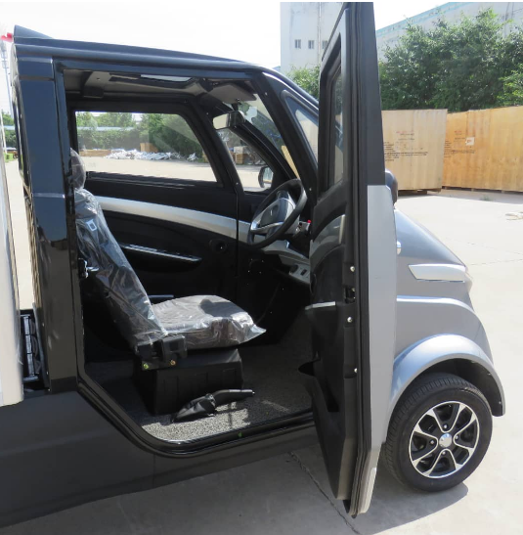
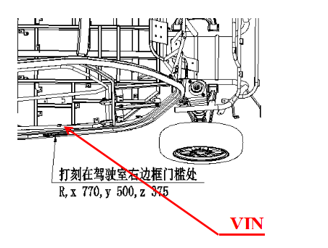
Motor No.: Motor outer surface housing.
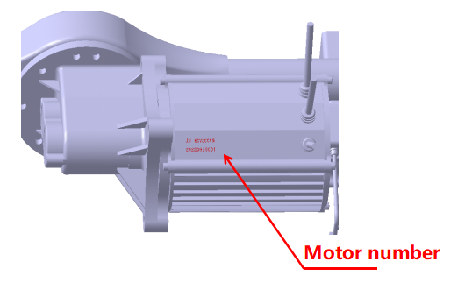

Vehicle documentation
The vehicle documentation includes vehicle number information, vehicle maintenance and warranty manual, and and user manual. So be sure to keep them in a safe place.

See the attached table for the list of on-board tools.
Power master switch
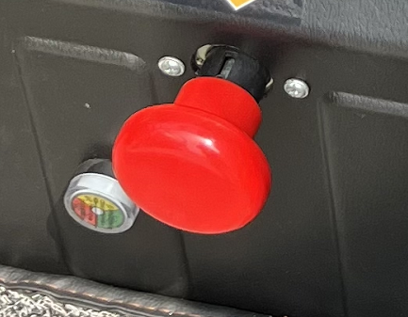
The main power switch is located under the main driving seat and in left of the decoration board of the seat box.
Pull up to turn on the power, press to turn off the power. This switch is only used for emergency power failure and maintenance
Power off, or stop for a long time, not frequent operation.

Auxiliary power switch
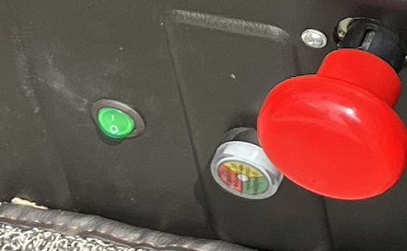
The auxiliary power switch is located under the main driver's seat and to the left of the seat trim panel.
When the auxiliary power switch is in the "I" position, the auxiliary power is turned on, and when it is in the "O" position, the auxiliary power is turned off.
Only by turning on the auxiliary power switch can the auxiliary battery provide power to the lithium battery BMS system and the vehicle can be drive or charge normally.
Please turn off the switch when the vehicle is parked for a long time, otherwise the auxiliary battery will be depleted.

Start switch
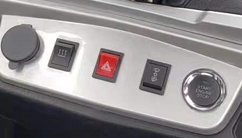
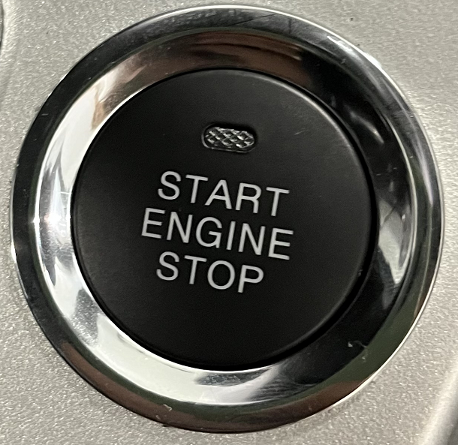
The start switch is a one-touch start located in the middle of the dashboard. Use the remote control key to open the door control lock, press the brake pedal, press the middle part of the start switch and then release it. At this time, the green indicator light on the start switch lights up, the vehicle power is turned on, the vehicle starts, and the vehicle is parked. After pressing the middle part of the start switch and then releasing, the green indicator light on the start switch is turned off, and the power supply of the whole vehicle is disconnected.

Combination dashboard

Combination dashboard overview（Lead Acid Battery）
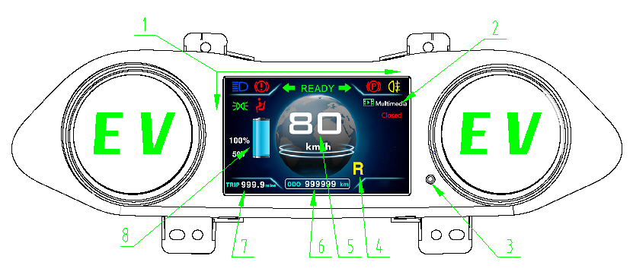
- Alarm light/indicator display area
- Multimedia
- Kilometers-(Km/h) and miles-(mph) of Switch button, Long press this button to reset the subtotal mileage.
- Gear position indication (The forward file is "D", the gap is "N", and the reverse file is "R")
- Speedometer
- Total mileage
- Subtotal mileage: It records the number of kilometers traveled by the user each time, which is the mileage before the zero clearance of this stage
- Battery power.

Combination dashboard overview（Lithium Battery Car）
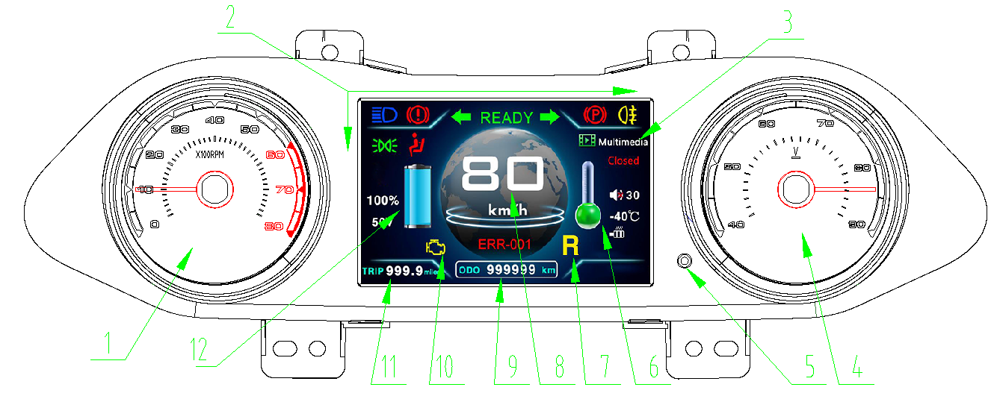
- Motor tachometer
2. Alarm light/indicator display area
3. Multimedia
4. Battery voltmeter
5.Kilometers-(Km/h) and miles-(mph) of Switch button, Long press this button to reset the subtotal mileage.

6.Motor temperature
7.Gear position indication (The forward file is "D", the gap is "N", and the reverse file is "R")
8.Speedometer 9. Total mileage 10. Failure indication (OBD)
11. Subtotal mileage: It records the number of kilometers traveled by the user each time, which is the mileage before the zero clearance of this stage.

12. Battery power.

Combination Dashboard

Warning light
The warning light is used to send an alarm to the vehicle status, indicating that the vehicle has a fault; the indicator light is used to indicate various functions of the vehicle.
 | high beam indicator light  This light comes on to indicate that the headlights are working properly in the high beam position |  | Brake fluid level warning light  When the brake fluid in the brake oil tank is short of brake fluid, the indicator light is on
 | Left and right steering and warning lights  When the warning light switch is turned on, the left and right turn signal indicators will flash; if the left or right turn signal light switch is turned on, the corresponding left or right turn signal indicator lights will flash |  | ready to run  When the system is ready, the indicator light is on; when starting up, the indicator light is on for self-test
 | position light  Turn on the switch of the position indicator light, the position light and the indicator light will be on |  | rear fog light indicator  On the premise that the front lights are turned on, when the rear fog light switch is turned on, the indicator light and the rear fog lights will light up
 | parking light  When the hand brake is pulled up, the indicator light is on; it is strictly forbidden to drive when the hand brake is pulled up and the indicator light is on |  | Fault alarm indicator（OBD）  The fault light is on and a fault code appears, and the fault of the vehicle's electronic control system can be found according to the fault code (applicable to lithium battery models, please refer to the attached table for details: List of system fault codes)
 | Driver's seat reminder warning light  In the case of power on, the driver leaves the vehicle, the indicator light flashes and beeps, and the N gear does not alarm. | 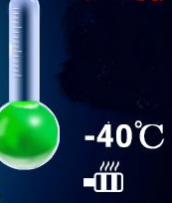 | Motor temperature indication  When the green indicator turns red, you should stop and check the actual temperature of the motor, and drive after the fault is resolved or the temperature drops

Hazard warning light switch

The hazard warning light switch is located on the lower part of the square instrument panel. Press the hazard warning light switch, all the turn signals on the vehicle are turned on and flash at the same time, and can be turned off by pressing the switch.
When the vehicle is driving in an emergency or abnormal state, and when it is in an emergency stop, use this button to turn on the emergency warning light, and all the turn signal lights will flash simultaneously.

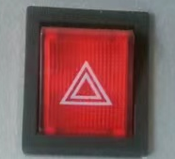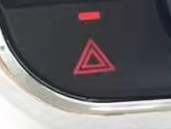

Warning:
- Neglecting to turn on the warning lights may cause serious accidents.
- When the vehicle in front suddenly slows down or is in a traffic jam and is waiting at the end of the traffic flow, the warning light should be turned on to attract the attention of the following vehicle drivers.
- In the event of an emergency, when the vehicle breaks down, or when the vehicle is towed, the warning lights should be turned on.

Light combination switch
●Rear fog light switch operation
Rear fog light switch operation by turning the knob on the inside of the control lever
Operate with the headlights on
◮ gear: At this time, the rear fog lights and instrument indicators are turned on
◮ "OFF" gear: Turn off the rear fog lights
In rainy, snowy and foggy weather, please turn on the rear fog lights of the vehicle to remind the vehicles behind and prevent rear-end collisions!
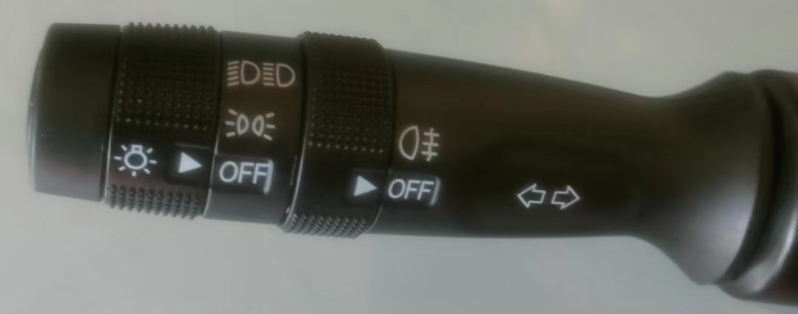

The light combination switch is located under the steering wheel, on the left side. The light combination switch controls the following operations:

Turn signal switch
Pull the light combination switch upwards, the right turn signal lamp of the front and rear combination lights flashes, and the right turn indicator light on the combination instrument flashes at the same time; pull the light combination switch downward, the left turn signal lamp of the front and rear combination lights The left turn indicator light flashes.
Lighting light switch operation
- Switch the lights on and off by turning the rotary knob at the end of the lever. There are three positions on the rotary knob:
- “OFF” gear: all lights are turned off
-  gear: At this time, the front and rear position lamps, license plate lamps and instrument lamps are turned on.
- Gear: At this time, the front and rear position lights, license plate lights, headlights and instrument lights are turned on.
- When the headlights are on, in the low beam state, push the lever down to switch to the high beam (high beam), when the high beam (high beam) is on, the high beam indicator light on the dashboard is on.
- If you need to briefly activate the high beam (high beam) as a passing signal, pull up the light control lever when the low beam is low, and let go after the signal is sent.

Wiper combination switch
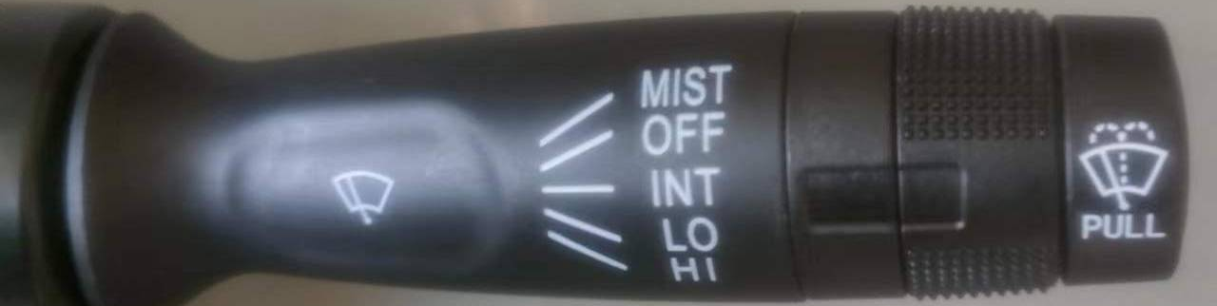
- The wiper combination switch is located under the steering wheel, on the right. The wiper combination switch controls the following operations:
- Glass washer：Slightly lift the handle upwards to spray washer fluid to the front windshield; the handle resets immediately after releasing it.
- Front windshield wiper：Turn the control handle clockwise to control the front windshield wipers.
OFF: Move the lever to this position and the wipers are off. MIST:Inching control, turn the control lever to this position, and the wiper wipes once.
LO HI：Turn the control lever to this position, the wiper motor starts to work, and the wiper continues to wipe。
The washer liquid storage pot is located in the front engine room, the liquid level in the washer liquid storage pot should be checked regularly and the washer liquid should be filled.
Note
- Before using the windshield wipers in cold weather when the windshield is icy, remove the snow and frost on the windshield first.
- Do not use wiper dust on a dry windshield, it will scratch the glass and damage the blades。
- Before using the wiper, please spray the washer fluid on the glass. Do not use the scrubber without washing liquid.
- Before driving, check whether the wiper and washer systems are working properly.
- When the ambient temperature is lower than 0°C, antifreeze detergent should be used.

Steering wheel/horn switch
Warning
It is forbidden to press the horn switch for a long time, and the single time of pressing the horn switch should not exceed 5 seconds
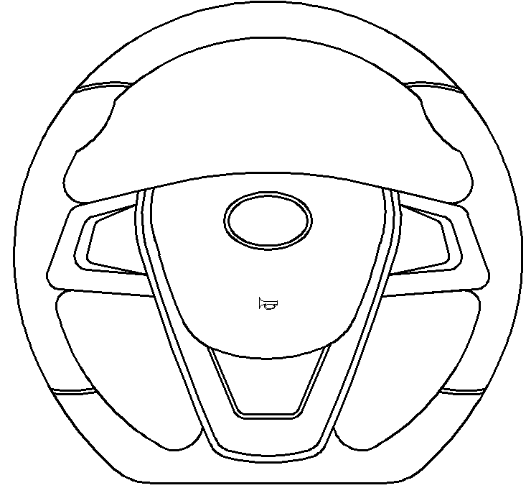
Horn
The horn button is located in the middle of the steering wheel.
After the vehicle starts, press the horn button and the horn will sound.

Air conditioner switch
The air conditioner switch is located in the middle of the lower end of the instrument panel (optional).
Click the A/C air conditioner switch switch on the upper right, the red light is on, and the air conditioner is turned on.
The lower right PTC is the heater switch, click on the red light to turn on the heater.
The upper left is the wind speed control switch, click once to increase the wind speed by one gear, and click once to turn off when the highest wind speed is reached.
Note: You must click the wind speed switch before clicking A/C or PTC to perform corresponding work!
The work of the air conditioning system will affect the mileage of the vehicle

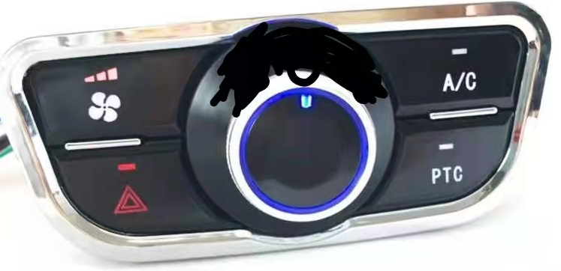

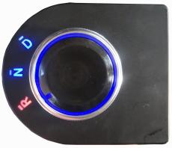
Shift switch
The shift switch is on the right side of the instrument panel, and there are 3 gears in total:
Neutral gear: Turn the switch to "N" gear, which means entering neutral gear.
Forward gear: Turn the switch to "D" gear, and the vehicle enters forward gear.
Reverse gear: Rotate the switch to "R" gear, and the vehicle enters reverse.

Warning
When the vehicle is driving in one direction, do not immediately change gears in the other direction. It is necessary to stop the vehicle for 2 seconds before shifting to the gear in the other direction, otherwise the motor may be damaged.

Foot pedal
The left pedal on the right front floor in the car is a brake pedal, which can be used for braking after stepping on it;
The right pedal on the right front floor in the car is an accelerator pedal. After the vehicle is started, the gear is shifted, and the vehicle accelerates after being stepped on slowly, and the vehicle cancels acceleration after being lifted.
Warning
Do not depress the brake pedal and accelerator pedal at the same time.
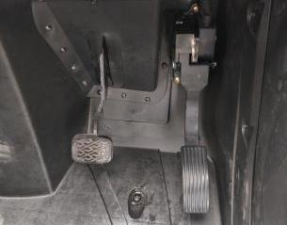

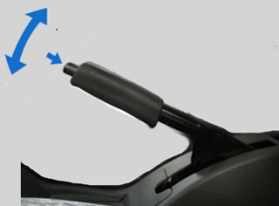
Parking brake

The parking brake lever is located on the floor to the right of the driver's seat.
Pull up the parking brake handle to brake the rear wheels of the vehicle.
When releasing the parking brake handle, first pull the parking handle up slightly, then press the unlock button on the top of the brake handle with your thumb, and then push the brake handle down to release the rear wheel brake.

Warning
- When leaving the vehicle after parking, be sure to use the parking brake.
- Do not run the vehicle when the vehicle is in the parking brake state, otherwise it will cause irreversible damage to the braking system.
- If the parking brake cannot be reliably locked or completely unlocked, the vehicle should be overhauled or contact the after-sales service center of our company.

Exterior mirror
Adjust the angle of the exterior mirror lenses to the desired position so that you can see clearly on both sides of the road behind the vehicle. The exterior rearview mirror is a convex mirror, which can see the scene behind the car more openly, and the objects in the
mirror appear to be closer than they actually are.
Warrning
Improper adjustment of the rearview mirror will affect the line of sight and increase the possibility of accidents. Therefore, please adjust the angle of the rearview mirror before driving, and check whether the mirror is damaged。

Multi-Media It is located in the middle of the upper part of the dashboard.
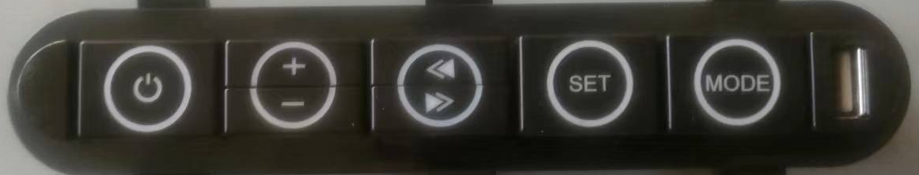
1. Power button: Start/close multimedia.
2. The volume volume of'+'increases gradually with each press and decreases gradually with each press.

3.Radio Search
- In the radio state, short step by step increases the audio rate, while short step by step decreases the audio rate.
- In MP3 playback mode, click "select" to select the track, and click "select" to select the track.
- In the radio state, long press "down" to search the radio station, long press "up" to search the radio station.
- In the state of MP3 playback, long press "track fast forward" and long press "play track fast backward".
4. "Mode" button mode switch key: used to change the working status of radio and external devices, the order of conversion is radio/USB/working mode. If there is no U disk, the prompt information will appear and the working status of the voice will be returned. The current track information will be displayed when reading and playing normally.
5. USB socket: It can be used to access U disk and play audio in U disk with multimedia.

Door lock
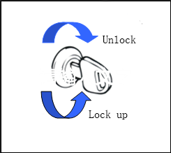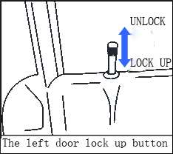
- The car is equipped with door lock central control device, which can control the door lock switch through remote control.
- The lock core of the car door is in the left front door.
- Turn the lock core counterclockwise when locking the door.
- When unlocking, turn clockwise.
- There are lock knobs on the inside of the left and right doors. If you press the lock knob, the door lock will be locked; if you lift the lock knob, the door lock will be opened.
- When locking a car door, the key is not needed, that is, first press the lock button, then pull the hand outside the door, then close the door and then put down the hand outside the door to lock.
- The door lock has anti-mistake lock function. If the door is closed carelessly, the lock button will automatically spring up and the lock core will still be open.

Glass rise and fall
The car adopts electric glass lifting. The glass lifting switch is at the arm of the door panel. The glass lifting switch is lifted upward, and the glass rises; the glass drops when the switch is pressed downward.
Attention
Do not place any part of the body on the glass ascending track when the glass rises in order to avoid pinch injury.
When the glass rises or falls to the limit, please release the electric elevator switch in time.

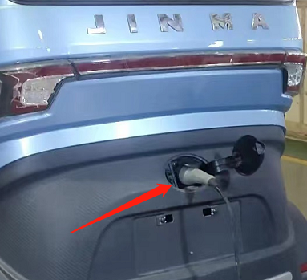
Charging port
The charging port of the vehicle is in the rear of the vehicle. Open the charging cover and insert the charging
plug into the charging port to charge. After charging pull out the charging gun and close the charging cover
to avoid splashing rain in rainy days.
- Before charging, the charging gun should be connected to the charging port, and then the charging plug should be connected to 220V power supply.
- After full charge, the charging plug should be pulled out from 220 V power supply, and then the charging gun should be pulled out from the charging port.
See the instructions on page 26 for specific charging methods.

Seater
Adjusting the seat to the right angle is a guarantee of comfort and safety in driving and riding.
Driver seat
A recliner is provided on the left side of the driver's seat to adjust the backrest angle. Lift the recliner handle, then adjust the backrest to the desired angle and lock the handle. The front and rear of the driver's seat has a front and rear sliding control handle, which lifts the handle to adjust the front and rear position, and the handle is locked.
Headrest
When adjusting the headrest, first press and hold the headrest unlock button, then pull up or down the headrest to adjust to the desired position, and release the button to lock the height of the headrest.
Attention
Adjust the headrest to a suitable position before driving, then lock it; adjust the headrest and backrest to the best position, and lock the seat after adjustment.

Warning
- The seat adjustment can only be made when the vehicle is stopped. Do not adjust the seat cushion, headrest and backrest during driving.
- When the adjustment is completed, it should be checked whether the seat is firmly fixed by moving back and forth. If it is not fixed firmly, it may cause sudden movement of the seat during driving, causing the driver to lose good control of the vehicle.
- The role of the pillow is to protect the safety of the head and neck of the person and reduce the possibility of neck injury in the accident. For protection, adjust the headrest to the back of the head to support the head to ensure effective protection of the headrest when impacted.

Safebelt
Wearing the seat belt correctly is an important guarantee for driving safety.
Pull the buckle on the seat belt, pass the shoulder strap through the shoulder, the waistband around the ankle, and then insert the buckle into the seat belt buckle seat, and hear a click, indicating that the seat belt is buckled. The seat belt can be unlocked by pressing the red button on the buckle.

Attention
- A seat belt must be attached during driving. Collision protection at the front of the driver and passenger can be provided with the seat belt correctly.
- The lower part of the seat belt should cross the pelvis, not at the waist, and the shoulder strap should be attached to the shoulder.
- When the seat belt is worn, it cannot be twisted and adjusted to a comfortable position as required. If the seat belt is not worn properly, it will not achieve safe protection.
- When driving, for infants and smaller children, if you do not have the correct constraints, please do not put them alone in the seat.
- All seat belts used in the event of a collision must be replaced. Because even if the defect is not seen, the strength and elasticity of the seat belt may be damaged.

- Do not bring the seat belt close to oil or chemicals. When the seat belt is contaminated with oil or chemicals, it should be washed immediately with neutral soap and then with water.
- No unit or individual is allowed to make changes to the seat belt and add additional mechanisms to prevent the seat belt from losing its function in an emergency.
- Make sure the seat belt buckle is inserted into the corresponding buckle.
- Do not attach the seat belt to items that are hard and fragile, otherwise the degree of injury will increase if an accident occurs.
- Two or more people are not allowed to wear a seat belt at the same time. When holding a baby or a child, do not attach the seat belt to the child, otherwise the injury to the child will be more serious in the event of an accident.
- Pregnant women should use the seat belt according to the doctor's instructions. The lower part of the seat belt should be placed in a low position to avoid the squeeze on the pregnant woman's stomach and fetus.
- Regularly check the belt for wear and damage. If the seat belt is excessively worn, contaminated and any damage, replace the seat belt immediately.

Driving method

Driving preparation

Running-in instructions
The new car running-in means that the new car is running at a small load and at a low speed in the initial stage of use, so that So that the accessories of electric vehicles can be run in. The initial running-in effect of the vehicle will have a great impact on the service life, reliability and economy of the vehicle. Therefore, please implement the running-in regulations when using the new car to ensure the performance and life of the vehicle.
New car running-in regulations：
● Recommended running mileage: 1000 to 1500 km.
● Do not drive the vehicle at the highest speed to avoid high-speed operation of the motor. It is recommended that the speed should not exceed 30 km/h.
● Should start slowly to avoid rapid acceleration and sudden braking.
● Avoid overloading the vehicle.
● Don't drive in a bad road.
● Always check the temperature of the hub and brake drum and adjust if necessary.
● Always check the condition of the fasteners and connectors to prevent loosening.
● Replace the gear oil for the first maintenance of the rear axle. The new rear axle shall be replaced for the first time in two months or when driving for 1000 kilometers.

Pre-departure check
Proper use of the vehicle and good driving habits are essential to improve the service life of the vehicle and to ensure the safety of the driver. Every time you drive, you should check the status of the important parts of the vehicle：
● Carefully check whether the steering system, brake system, acceleration switch, parking brake handle operation is flexible, whether it is good return, whether there is stuck or heavy phenomenon, once the abnormality is found, timely repair and elimination.
● Check the tire pressure and wear and tear of each tire, and inflate or replace it in time.
● Confirm that the function indicator, light, and speaker are normal. If the fault is not properly corrected, you can drive.
● Check the power status. When the start switch is turned on, if the power meter shows that the power is ≤ 20%, at this time, it is not allowed to drive, so as to avoid the running out of the middle energy, the vehicle must be charged immediately.

Driving

Vehicle start

Check the vehicle before preparing for driving. After confirming that the vehicle is in good condition, adjust the seat and press the start switch to drive. Process operation：
1. Press the center key unlock button.
2. Press the start switch on the instrument panel to check the remaining battery capacity and vehicle status.
3. Rotate the shift switch on the right side of the instrument panel to position it in the “D” position.
4. Release the parking brake and slowly turn the acceleration switch to start the vehicle.
5. The speed of the vehicle is controlled by the acceleration of the rotary handle, the acceleration of the rotary acceleration is accelerated, and the acceleration of the acceleration is released.
6. If you want to start on a half slope, press the brake pedal or pull up the parking brake. While releasing the brake pedal and the parking brake, turn the acceleration lever to climb the slope.
Attention
● Do not drive the vehicle after taking alcohol or anesthesia to ensure the safety of yourself and others.
● Avoid driving the vehicle in situations of fatigue, illness, emotional excitement or excessive stress.

Shift
● When the vehicle is stopped, the shift switch should be placed in the “N” position.
● Turn the shift knob to the “D” position, turn the acceleration lever, and the vehicle will start moving forward.
● Turn the shift knob to the “R” position, and the “R” indicator on the instrument cluster will light. At this point, the acceleration will be turned and the vehicle will start to go backwards.
Attention
● When the vehicle is moving forward, it is not allowed to change to reverse gear reverse. Only when the vehicle is completely stopped can it enter the reverse gear.
● When the shift is made, the acceleration handle must be released. After the gear is changed, the acceleration can be driven.

Turn direction
When turning, decelerate and the turning speed must not exceed 10Km/h. Turn on the turn signal to be turned into the direction, look at the rear view mirror, and observe the vehicles in both directions to enter the lane, whistle properly, turn the direction with both hands, and slowly drive the vehicle into the lane.

Multiple driving
Energy saving driving
● Avoid unnecessary parking because the acceleration after deceleration will consume more power.
- No special circumstances, try to accelerate slowly, avoid fierce acceleration, and consume more power.
● Maintain a steady cruising speed.
● Avoid high-speed driving, the maximum speed will consume power sharply.
● Keep the load as small as possible and reduce the weight of the car to save energy.
● Maintain normal tire pressure and reduce driving resistance.
● If not necessary, try to turn off the heating and cooling system.
High Speed Driving
● The higher the speed of the vehicle, the longer the braking distance. Please control the braking pedal according to the speed and the required braking distance.
● When high speed passes through a mountain pass, over a large vehicle or through a tunnel entrance, it will be affected by the cross wind, so the speed of the vehicle should be reduced to avoid accidents.
● Driving at the lowest speed in rainy and snowy days, because of low visibility, wet and slippery road surface, it is easy to slip, leading to steering and braking out of control.

Multi-mode driving
Vehicle Load Driving
Strict control of the vehicle load within the standard load, in order to avoid accidents in vehicle driving.

Driving on wet and slippery road
When a vehicle runs on wet or wet road surface or snow-covered road surface, the adhesion between tire and ground decreases. Vehicle speed should be lowered to avoid rapid start, acceleration, steering and braking. Brake should be used as little as possible and decelerated in advance.
Attention
- When driving on snow in winter, it is necessary to change the snow tires or install anti-skid chain on the ordinary tires according to the situation.
2.Snow tires are specially designed for driving on ice and snow roads. When changing, snow tires of the same size as the standard tires of vehicles should be used. Don't mistake the rotation direction of the tires. The same tires (trademarks, specifications and tread patterns) should be installed on the two rear axles to ensure the maximum safety of driving and braking. In addition, not use in normal environment without ice and snow, its performance will not be as good as standard ordinary tires.
3.The use of skid-proof chains in snow must follow the relevant laws and regulations, and only be installed on the driving wheels of vehicles. The maximum height of the protruding tire contour is about 10 mm by using the anti-skid chain with smaller contour section. When driving, please try to keep driving at a low speed, do not drive on snow-free roads for a long time, so as not to cause damage to vehicles and roadbed.

Braking, stoping and parking
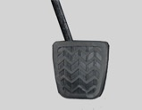
The pedal on the driver's right floor is the brake pedal, which is used to brake the vehicle.

Waring
Do not press the brake pedal while turning the accelerator on the direction handle.

When parking, the accelerator is loosened first, then the brake pedal is slowly stepped down, and the vehicle stops gradually. After parking, pull up the parking brake handle, brake the vehicle to prevent slipping, and then put the shift switch in the "N" gear position.
Emergency parking is a compulsory braking measure in case of danger in driving. At this time, the direction handle should be grasped steadily, the acceleration handle should be loosened first, then the brake pedal should be depressed, and the parking brake handle should be pulled up to stop the electric vehicle rapidly. Emergency parking is used in special unexpected situations. It should not be used frequently in order to avoid premature damage to tires and related components.。

Attention
- If there is often a whistle when braking, it should be checked at our after-sales service station.
- Do not brake continuously for a long time or rest your foot on the brake pedal while driving. This will cause overheating or permanent damage to the brake.
- When water, sediment and dust enter the brake, the brake efficiency will be reduced. The brake should be cleaned and kept dry.

Vehicle parking
If the vehicle is idle for a long time and lasts more than one month, please follow the precautions:
● Place the vehicle in a covered flat area. The site should be dry and ventilated.
● Check to ensure that the parking brake handle is tightened.
- Cut off the power supply of the high voltage system through the main switch of the power supply.
● Check its power consumption once a month and charge it in time.
● Protective wax should be used to clean and protect the painted parts on the body.
● Sprinkle talc powder on the rubber sheet of the glass wiper and don't keep it close to the glass.
● Open a slight gap in the window to ensure ventilation.
● Cover the vehicle with a sleeve made of fabric or porous plastic cloth. Do not use the sleeve made of sealed plastic cloth to prevent the evaporation of moisture on the surface of the car.
● Pressure the tire inflation to 50 Kpa higher than the conventional inflation pressure, and check the tire pressure regularly.
Emergency management
In case of dangerous emergencies during driving, please press the danger alarm light switch immediately, stop the vehicle after driving into the safety zone, and place a triangular warning sign at the distance of the coming direction meeting the requirements of the regulations. The reflecting surface is directly in the direction of the coming vehicle.
Take steps
Once an accident occurs, we must keep calm, and then choose the appropriate treatment according to the situation.
● If you are not directly involved, stop at least 10 meters away from the scene of the accident.
● Stop on the highway and don't block the emergency passage.
● Pull out the start key of the accident vehicle and turn on the danger warning signal.
● At night, headlights are used to illuminate the scene of the accident.
● If the door is blocked, do not try to break the front windshield out, because it is difficult to break, side windows and rear windows are easier to break.
● A red triangle warning sign is placed at a clear distance to show the accident.
● Call the emergency organization and report as accurate information as possible.
● When rear-end collision occurs on the highway, especially in the case of low visibility, the risk of collision by subsequent vehicles is very high, so it is necessary to leave the vehicle immediately and withdraw to the safety zone outside the guardrail.
● If you smell fuel or other chemicals, don't smoke or light a fire and stay away from the area.
● When a fire breaks out, use fire extinguishers, blankets or sand to extinguish it even if it is very small. Never use water.
● Contact the local traffic management department in time to seek help.

Emergency management
Wounded personnel management. If someone is injured, never abandon the injured person, even if it is not directly related to the accident, but also to provide help.
● Don't look around at the injured.
● Contact professional assistance and stay nearby to comfort the injured so that they do not panic.
● Release or cut the seat belt that restricts the injured.
● Do not give the injured anything to drink, so as not to aggravate the internal injury.
● Do not move the injured person except under special circumstances.
● The injured person can only be removed from the vehicle in case of fire, submergence, falling off a cliff or similar emergency danger. When removing the injured person, do not pull the limbs or bend the head, try to keep the body flat.
Emergency medicine kit. Emergency medicine kits should be provided onthe car for emergency use.

Charging
When charging, please strictly follow the following steps:
1、Close the vehicle start switch and pull up the parking brake handle.
2、Open the charging cover and insert the charging gun into the socket. The charging socket should be inserted into the bottom.
3、Connect charging plug end to "220V16A" AC power supply.
4、Time required for battery from empty to full charge: 7-8 hours for lead-acid vehicle; Lithium battery model: 3-4 hours for 64V105Ah lithium battery, 6-7 hours for 64V206Ah lithium battery.
5、After charging, the charging plug is pulled out from 220V power outlet, then the charging gun is pulled out and the charging mouth cover is closed
Warning!
1. The actual service life of vehicle power batteries largely depends on your use and maintenance. In order to ensure the longest service life of batteries, please do your best to charge and use batteries according to the following tips.
2. Every time the vehicle is charged, try to fully charge the electricity and then use it. Otherwise, the arc will occur when the power cord is pulled out, which will affect the service life of the charging line.
3. When the instrument shows that the battery capacity is less than 20%, the vehicle battery should be charged as soon as 4. possible to avoid damage to the battery, resulting in the reduction of battery capacity and life.
For other matters needing attention in battery use and maintenance, please refer to the battery maintenance section.

Charge
Warning
- Before charging the vehicle, connect the 220V power cord, leakage protector and 16A charging socket in strict accordance with the above regulations. It is strictly forbidden to use the plug to transfer the charging.
- Please strictly follow the above charging steps to avoid danger.
- During charging, the vehicle should be placed in a well ventilated area for charging.
- If there is abnormal sound, odor, sparking, smoke, etc. during charging, please cut down the power and check the problem immediately
- . Do not charge in the high-humidity or high-heat environment.
- The charging input voltage is limited to the 220V power frequency voltage of the main power supply. Do not use above the main power supply and above the power supply frequency
- Use the own charger of the car, otherwise the battery may be destroyed.
- No charging in the fast charging station。
- During the charging process, avoid touching the charging part of the vehicle to prevent the risk of electric shock.
- In summer driving，the temperature of the battery is high ， charging after the cooling of the battery, no charging in the Sun
- In the cold winter, the performance of the input or output will be lower，you need charge immediately after using.

Maintenance and Mending of the Vehicle

Maintenance of Parts and Components
After a long period of driving, the friction surface of moving parts will wear and tear, and the working state of each system and component will change. In order to ensure that the vehicle is in good working condition and prolong the service life of the vehicle, regular maintenance must be carried out according to the regulations. Inspection, adjustment, lubrication and other maintenance items are specified in the regular maintenance table. The maintenance cycle is counted by mileage or months of the vehicle. If the vehicle is often used in harsh conditions (such as heavy load, high-speed driving, etc.), the maintenance cycle must be shortened accordingly.
For the items listed in the regular maintenance table, it is recommended to go to the professional maintenance point for maintenance; for the other simple items, you can refer to the method described in this manual for maintenance.
Warning
1.If you don't know much about the vehicle, the maintenance of the vehicle may cause damage to your vehicle.
2.When inspecting and maintaining electrical components, it must be carried out in case of power failure in order to avoid accidents.
3.When jacking up a vehicle with an onboard jack, it is not allowed to enter the lower part of the vehicle.
4.Do not touch the positive and negative poles of the battery at will, in order to avoid the accident of short circuit.
5.Whether the motor is running or not, please do not disassemble the electrical components or batteries when the switch is started.

Battery
Lead-acid of the vehicles are equipped with a set of power lead-acid maintenance-free batteries (The voltage 60V);
Lithium battery of the vehicles are equipped with a power lithium battery (The voltage 64V) and an auxiliary battery (12V32Ah). The power battery is located under the rear seat, the power battery is a lithium iron phosphate battery. And the auxiliary battery is a lead-acid maintenance-free battery, located under the main driver's seat. The auxiliary battery is only used for starting the lithium battery and the central control system (normal power supply).
The using methods of battery charging.
Standard charging: Use the on-board charger to charge. The charging indicator light flashes red to indicate it is charging, and the green light is always on to indicate it is fully charged.
Low temperature charge: below 0 ℃ charging, can affect the service life of the battery, please try to avoid charging at low temperature.
High temperature charging: in summer, please place the battery pack in a cool and ventilated place to avoid direct sunlight.More than 45 ℃ charging, it will affect the service life of the battery pack, please note.
- Total switching button and assist switching button need to be open.
- When charging, unplug the start switch key and pull the parking brake.
- In the process of charging, if you smell a bad smell or the temperature is too high, please stop charging immediately and send to the agency for maintenance.
- Try to use the battery pack after it is fully charged. Otherwise, it will lead to insufficient driving range and battery life reduction.
- After driving our vehicle in winter, you need charge soon. After the battery discharge, system working temperature above 0 ℃, can reduce the impact of low-temperature charging the battery life.

Battery
The battery discharge
It is forbidden to over discharge the battery, which will do great harm to the service life of the battery.
In the process of discharging the battery pack, try to make the battery pack in the state of small current discharge, which can extend the driving range and battery life.

  - Battery storage and recharge
Battery storage environment temperature is -20 ~ 45 ℃, the optimal storage temperature is 0 ~ 25 ℃. In the process of storage and transportation capacity will be a loss, battery before use, please use the standard charging manner for electricity.
Warning
Precautions for use:
- Don’t open the inside battery privacy as the high voltage may do harm to you.
- The connection of the battery can’t be any short circuit.
Do not put the battery into the liquid, such as water, gasoline, drinks, etc., also can not be put in a damp place or water.
- Do not apply external force to the battery or make it fall from high altitude.
- When the battery is not in use, it should be stored in a dry and cool place after being fully charged, insulated to prevent heavy pressure and contact with children, and fully charged every 1 month.
- Please do not discard the scrapped battery, please return the scrapped battery to the dealer

Battery Charger
Our vehicle has smart charger， the charger is under the driver’s seat。There is a charging indicator on the left side of the decoration board of the main driver's seat. When the vehicle is charging, the indicator light will be on to show the current charging status of the power battery.
Charger safety guide
● Since the charger has many automatic protection functions, there is no need for special care when charging.When the battery is fully charged, the charger will automatically stop charging.
● It is strictly prohibited to disassemble the machine for repair or debugging. If it has any problems, pleased go to the repair station of our company.
● It is strictly prohibited to disassemble the machine for repair or debugging.
● Ac power supply above 16A specification, requires the three core cable with grounding and correct grounding, wire diameter area not less than 2.5 square mm.
● The charger is strictly prohibited to be used in the environment with high humidity and heat.Avoid blocking the inlet and outlet of the charger.
● If there is abnormal sound, smell, spark, smoke and other phenomena in the charging process, please immediately cut off the power supply and check the problem.
● The input voltage of the charger is only limited to the 220V power frequency voltage of the municipal power supply, which is higher than the municipal power supply and higher than the power frequency voltage.

The controller
The car controller is installed in the rear seat back and inside the car body rear decorative panel.
Electronic control devices should be inspected every three months.After the power is turned off, the filter capacitor in the controller unit should be discharged for several minutes. Do not flush the electrical parts with water. Clean brush or high pressure gas can be used to remove dust.The inspection contents are as follows:
● Check the connection of battery, motor, motor controller and contactor.
● Check and keep battery, motor, motor controller and contactor clean.

Rear Suspension
Warning
- Rear axle gear oil too little or too much will damage the rear axle. Too much gear oil will overflow, too little gear oil will speed up the excessive wear of the gear. Therefore, check the oil level, must be accurate.
- Other lubricants of the same grade may be used, but lubricants produced by different manufacturers or according to different standards shall not be mixed for use. When changing the oil, you must first drain the old oil, and then inject new oil.
- Please choose the right gear oil according to the local environment, otherwise it will be harmful to the rear suspension.

There are no parts in the rear axle that can be repaired by users. Do not open the rear axle for repair without permission to prevent damage.
The rear axle gear oil models are 80w-90 and gl-4. The new rear axle shall be replaced for the first time in two months or when driving for 1000 kilometers, and then it shall be replaced according to the provisions in the regular maintenance project .The steps are as follows:
1. Use a wrench to unscrew the rear refueling screw and remove the drain bolt at the bottom of the rear axle.
2. Put the gear oil into the container. After the gear oil is cleaned, tighten the cleaned oil drain bolts clockwise.
3.Put the special refueling equipment at the refueling port at the rear of the rear axle, and refill the rear axle gear oil. The reference filling volume is 600mL.

The braking system
Check and replace brake pads regularly and fill brake hub bearing lubricating oil.
The brake fluid
The brake oil cup of this car is located in the front cabin, the brake fluid is DOT3 type brake fluid, and the level of the brake oil cup should be between the upper and lower cutting lines.If the liquid level is lower than the bottom line, the same type of brake fluid should be added, and mixed use of different brands of brake fluid is prohibited.
The brake pedal
When the brake pedal is pressed to the bottom, the vertical distance between the pedal and the front wall plate shall not be less than 19mm, and the brake force of the pedal is about 278N.When the brake pedal is pressed to the bottom, the following situations should be timely checked:
Insufficient braking force;Unstable braking force; Pedal stroke is too large;Pedal block;Brake noise;The pedals beat.
Parking brake handle
When the parking brake handle is stuck on a tooth between 4-7 ratchet teeth, the wheels should be able to effectively lock.In this range, if the parking brake can not lock the vehicle, or unlock can not be completely unlocked, should contact the after-sales service station maintenance personnel for inspection and maintenance.

Warning
- Because of the front disc brake, once the brake friction wear, brake level will gradually decline.
- Users need to check the liquid level in the brake fluid storage pot frequently, and the brake fluid level should be between the upper and lower engraved lines of the liquid storage pot. If the liquid level is lower than the lower engraved line, the brake fluid needs to be replenished. The brake fluid level is lower than the critical point, and the liquid level alarm light on the instrument display interface will light up.
- Check brake should be in the motor stop state, at the same time release parking brake for inspection.
- Do not use brake fluid that is not of the specified model or mixed with different models. Do not use brake fluid that has been stored for a long time or in a container with no cover.
- In order to prevent the potential safety hazard caused by the unsmooth movement of the brake pedal, the user shall not install a dust mat under the brake pedal.

Tires
● Low tire pressure will make the tire overheating, faster wear and tear, difficult driving, power consumption.
●When the tire pressure is too high, the vehicle vibrates seriously and the balance drops, which makes the tire wear seriously.
●The tire must be replaced when the tread wear reaches or exceeds 1.6 mm.
●When using tires, be careful not to hit kerbs , potholes, or other obstacles. Driving long distances on bumpy roads can damage tires.
●Check the side wall of the tire regularly for cut marks, abnormal expansion or irregular wear of the tire.
●Avoid overload when driving, in case of serious damage to tires and affect vehicle performance.
●If a tire is punctured, stop and replace it immediately to avoid damage to the tire, rim, suspension, and steering system.
●Rubber tires can develop cracks, a sign of aging, even when they are infrequently used. In any case, tires that have been in service for more than 6 years should be professionally tested for continued use.
●The tire pressure check needs to be done after the tire has cooled, otherwise an incorrect reading will be obtained.
●When the tire is inflated, it should be slowly inflated while checking the tire pressure until it reaches the specified value of 220KPa.
●Changing tires of different sizes will result in wrong speed and mileage readings.
●The impact of foreign matter on the road surface and the objects passing over the road surface will affect the normal positioning Angle of the wheel, which needs to be corrected by the authorized maintenance center of our company.
● please use our tires to ensure the performance and driving safety.

Tires
Tire replacement
● Use a wheel wrench to loosen the nut that replaces the tire, but do not remove it.
● Lift the vehicle with a jack.
● Remove the wheel nuts and tires.
● Install a new tire and tighten the wheel nut by hand to secure the rim.
● Lower the jack and use the wheel wrench to tighten the wheel nut with the specified torque (front wheel: 120±10N.m; rear wheel: 70±5N.m) in the order of the cross.

Vehicle anti-corrosion
The paint on the body surface is easily damaged by dirt, such as salt, chemicals, tar, sap, animal waste, industrial pollution and dust, which may corrode the paint layer and remove them as soon as possible.
It can be cleaned with a neutral detergent. It is strictly forbidden to use an acid or alkaline detergent. Always rinse the cleaner with clean water after washing. If the surface of your car is damaged or the paint is peeled off, repair the damaged area immediately and do not expose the metal to the air. Moisture, dust, and dirt under the car interior cushion may accelerate corrosion. Always check to make sure the car interior is clean and dry. Do not park your vehicle in a damp or poorly ventilated area. Do not wash the vehicle in the garage.

Interior maintenance
Vehicle interiors use different maintenance methods depending on the material:
● Seats and ceilings can be cleaned with a soft cloth dampened with a mild detergent.
● Plastic materials such as instrument panel and side trim panel can be used with water or a small amount of soap or soft detergent. After immersing in a solution with a sponge or a soft cloth, wipe it gently. After a few minutes, wipe it with a clean soft cloth. Until it is clean.
● Dust and debris on the floor can be cleaned with a vacuum cleaner, then wipe the soil with a clean soft cloth dampened with soap or detergent, then rinse with water.
Note
- When cleaning the vehicle, do not use flammable materials such as thinner, benzine or benzene, or use alkaline or acidic household cleaners.
- When cleaning the inside of the vehicle, prevent the cleaning agent or water from flowing into the gap of the electrical device to prevent short circuit of the electrical device.

Vehicle Body
Cleaning method
● Rinse the debris and debris of the vehicle floor and wheels with high-pressure water.
● When rinsing the outer surface, wipe it gently with a soft cloth. Do not rub with hard objects to avoid damaging the surface.
● Use a soft cloth to remove the neutral detergent and gently rub the surface. Do not use acid or alkaline cleaner.
● Once the dirt is removed, clean it immediately with water.
● After washing, wipe the water droplets on the surface of the vehicle with a soft cloth and dry it naturally.
● Carefully inspect the paint layer on the surface of the vehicle. If it is scratched, please follow the steps below: clean and dry the damaged surface; use a small brush to gently apply the same color to brush the wound; completely dry in the shade.
Paint maintenance
● Please use a special wipe to clean.
● Avoid contact with strong acids and bases.
● Avoid contact with volatiles such as gasoline and engine oil for a long time. If there is a small amount of contact, please wipe it off with a special wipe.
● Avoid hard objects touching the surface of the paint film to avoid scratches.
●Wax coating. It is recommended that you apply wax and polish once or twice a year to protect your body paint and beautify your car. Please use good quality car wax and polish, and pay attention to the manufacturer's instructions

Common troubleshooting methods
Item | Fault phenomenon | Failure analysis | Method of exclusion
The vehicle is not driving properly | The voltmeter has instructions | Gear changer damage | Replace the new shifter
The vehicle is not driving properly | The voltmeter has instructions | Controller damage | Replace the new controller
The vehicle is not driving properly | The voltmeter has instructions | Accelerator damage | Replace the new accelerator
The vehicle is not driving properly | Can only move forward | Gear changer damage | Replace the new shifter
The vehicle is not driving properly | Can only move forward | Controller damage | Replace the new controller
The vehicle is not driving properly | Can only go backwards | Gear changer damage | Replace the new shifter
The vehicle is not driving properly | Can only go backwards | Controller damage | Replace the new controller
Charging system | The charging indicator does not light | The charger and battery cable are not connected. | Connect the connection
Charging system | The charging indicator does not light | Charging cable is not connected | Reinsert the charging cable
Charging system | The charging indicator does not light | Charger damage | Replace
Charging system | Battery charging is not full | The output cable is too long or the wire diameter is too thin, causing the line voltage to drop too much. | Restore the output cable to standard length
Charging system | Fully lit when turned on | Check whether the connection between charger and battery is loose or falling off | Normal connection
Brake failure | Brake weakness | Brake line leak | Repair or replace
Brake failure | Brake weakness | Gas in the brake line | Net gas
Brake failure | Brake weakness | Brake master cylinder rubber piston failure | Replace
Brake failure | Brake weakness | Brake cylinder piston failure | Replace
Brake failure | Parking brake is poor | Brake cable too loose | Adjust
Brake failure | Parking brake is poor | Brake cable stuck | Repair or replace
Brake failure | There is abnormal noise in the rear axle | Rear axle gear damage | Replace

System Fault Code List

Battery BMS system failure (lithium battery model)
- Level 3 fault
Fault level | Fault Name | Code | Fault description | Processing measures | Components
Level 3  （1-20） | Severe overheating alarm | 01 | Battery maximum temperature > battery high temperature protection value. | The BMS reports that the power limit of the motor reaches 0, 3S and then disconnects the discharge contactor | BMS
Level 3  （1-20） | The total voltage is too high | 02 | Total voltage > total voltage protection upper limit. | The BMS reports that the power limit of the motor reaches 0, 3S and then disconnects the discharge contactor | BMS
Level 3  （1-20） | total voltage ultra -low | 03 | Total voltage < total voltage protection lower limit. | The BMS reports that the power limit of the motor reaches 0, 3S and then disconnects the discharge contactor | BMS
Level 3  （1-20） | Severe overcurrent discharge | 04 | Discharge current > discharge current protection value | The BMS reports that the power limit of the motor reaches 0, 3S and then disconnects the discharge contactor | BMS
Level 3  （1-20） | monomer is too high | 05 | Severe overcurrent may be caused by a short circuit. | The BMS reports that the power limit of the motor reaches 0, 3S and then disconnects the discharge contactor | BMS
Level 3  （1-20） | Single is too low | 06 | The highest voltage of the battery cell > the high voltage protection value of the single battery | The BMS reports that the power limit of the motor reaches 0, 3S and then disconnects the discharge contactor | BMS
Level 3  （1-20） | Insulation resistance is too low | 07 | The minimum voltage of the battery cell < the low voltage protection value of the single battery | The BMS reports that the power limit of the motor reaches 0, 3S and then disconnects the discharge contactor | BMS

Level 2 failure
Fault level | Fault Name | Code | Fault description | Processing measures | Components
Level 2（21-60） | High temperature alarm | 21 | Battery maximum temperature > battery high temperature alarm value | BMS reports, motor power limit to 50% | BMS
Level 2（21-60） | low temperature alarm | 22 | Minimum battery temperature < battery low temperature alarm value | BMS reports, motor power limit to 50% | BMS
Level 2（21-60） | Single high voltage | 23 | The highest voltage of the battery cell > the alarm value of the high voltage of the single battery | BMS reports, motor power limit to 50% | BMS
Level 2（21-60） | Low monomer voltage | 24 | The minimum voltage of the battery cell < the low voltage alarm value of the battery cell | BMS reports, motor power limit to 50% | BMS
Level 2（21-60） | current overcurrent | 25 | Discharge current < discharge current alarm value | BMS reports, motor power limit to 50% | BMS
Level 2（21-60） | BMS internal communication failure | 26 | The communication between the BMS main control module and the slave control module is abnormal | BMS reports, motor power limit to 50% | BMS
Level 2（21-60） | Low SOC | 27 | SOC < 10% | BMS reports, motor power limit to 50% | BMS
Level 2（21-60） | The battery pressure difference is large | 28 | The maximum and minimum voltage difference of the battery cell > the voltage difference limit value | BMS reports, motor power limit to 50% | BMS
Level 2（21-60） | Large temperature difference between batteries | 29 | Battery maximum and minimum temperature difference > temperature difference limit value | BMS reports, motor power limit to 50% | BMS

Level 1 failure
Fault level | Fault Name | Code | Fault description | Processing measures | Components
Level 1（61-99） | Low SOC | 61 | SOC<20% | The instrument displays fault codes | BMS
Level 1（61-99） | Large battery voltage difference | 62 | The maximum and minimum voltage difference of battery cells > differential pressure alarm value | The instrument displays fault codes | BMS
Level 1（61-99） | Large temperature difference between batteries | 63 | Battery maximum and minimum temperature difference > temperature difference alarm value | The instrument displays fault codes | BMS
Level 1（61-99） | Charger hardware failure | 64 | BMS receives the feedback information from the charger and reports the corresponding fault | The BMS requests the charger to stop charging, and the indicator displays a fault code | BMS
Level 1（61-99） | Charger temperature failure | 65 | BMS receives the feedback information from the charger and reports the corresponding fault | The BMS requests the charger to stop charging, and the indicator displays a fault code | BMS
Level 1（61-99） | Charger voltage limit power failure | 66 | BMS receives the feedback information from the charger and reports the corresponding fault | The BMS requests the charger to stop charging, and the indicator displays a fault code | BMS
Level 1（61-99） | Charger input voltage failure | 67 | BMS receives the feedback information from the charger and reports the corresponding fault | The BMS requests the charger to stop charging, and the indicator displays a fault code | BMS
Level 1（61-99） | Charger output overcurrent | 68 | BMS receives the feedback information from the charger and reports the corresponding fault | The BMS requests the charger to stop charging, and the indicator displays a fault code | BMS
Level 1（61-99） | Charger startup failure | 69 | BMS receives the feedback information from the charger and reports the corresponding fault | The BMS requests the charger to stop charging, and the indicator displays a fault code | BMS
Level 1（61-99） | Charger communication failure | 70 | BMS receives the feedback information from the charger and reports the corresponding fault | The BMS requests the charger to stop charging, and the indicator displays a fault code | BMS
Level 1（61-99） | Charger battery connection failure | 71 | BMS receives the feedback information from the charger and reports the corresponding fault | The BMS requests the charger to stop charging, and the indicator displays a fault code | BMS

Electronic control system failure
Code | Name | Controller alarm mode | Processing method | Fault countermeasures
101 | high pedal failure | Long beep | not running | Check pedals and return
102 | precharge failure | one long and two short | not running | Check the power board for obvious damage, and check whether the cables between the power board and the control board are reliably connected.
103 | overcurrent | One long and three short | shutdown | The first step is to adjust the control parameters, and the second step is to adjust the output torque. If the problem cannot be solved, return it to the factory for repair.
104 | Controller overheating | One long and four short | shutdown | Check whether the fan works normally and whether the air duct is smooth.
105 | Main circuit power off | one long five short | shutdown | Check the main circuit insurance, contactor, emergency stop switch, etc.
106 | Current sampling circuit failure | one long six short | shutdown | Return to factory for repair.
107 | Encoder failure | one long and seven short | shutdown | Check the encoder harness, check the encoder for damag
108 | BMS failure | One long and eight short | shutdown | The BMS is faulty or the battery pack is abnormal.
109 | battery pack undervoltage | One long and nine short | shutdown | Need to charge.
110 | battery pack overvoltage | One long and ten short | shutdown | Check whether the battery is normal, and reduce the energy feedback appropriately.
111 | motor overheating | One long and eleven short | shutdown | Stop cooling or increase the cooling mode of the motor.
113 | Accelerator failure | One long and twelve short | shutdown | Check whether the accelerator line is properly connected. If damaged, return to factory for repair.

Vehicle parameters

J2 Parameter
NO | Configuration | Item | Standard
1 | Parameter | L*W*H(mm) | 2390×1200×1700
2 | Parameter | Axle Base (mm) | 1580
3 | Parameter | Wheel Base（F/R）(mm) | 1000/1030
4 | Parameter | Mini ground clearance （mm） | 140
5 | Parameter | Curb Weight(kg) | 376
6 | Parameter | Person | 3
7 | Parameter | Brake Mode（F/R） | DISC/DRUM
8 | Parameter | Brake Type（F/R） | Hydraulic system
9 | Parameter | Rim type （F/R） | 4.0B×12/4.0B×12
10 | Parameter | Tire Specification (F/R ) | 135/70R12,145/70R12
11 | Parameter | Tire pressure（F/R）kPaz） | 250±20
12 | Parameter | Transmission type | Motor rear drive
13 | Electrical component parameters | Type of Motor | 60V3000W
14 | Electrical component parameters | Brand | DEPUDA
15 | Electrical component parameters | Type | AC Motor
16 | Electrical component parameters | Rated Voltage/ Rotating Speed/ Torque/ Power (V/r/min/N.m/kW) | 60/3000/9.55/3
17 | Electrical component parameters | Battery type | Lithium iron phosphate battery
18 | Electrical component parameters | Battery Capacity Ah | 105
19 | Electrical component parameters | Nominal Voltage of Battery Capacity （V） | 64
20 | Electrical component parameters | Power consumption per 100 kilometers (kW.h/100km) | 7.167
21 | Electrical component parameters | Undervoltage protection value (V) | 52
22 | Electrical component parameters | Overcurrent protection value (A) | 175
23 | Electrical component parameters | Charger input power supply voltage/frequency (V/Hz) | 220±15%/45-65Hz
24 | Main performance indicators | Maximum speed (km/h) | 45
25 | Main performance indicators | Driving mileage (km) | 90～120
26 | Main performance indicators | Gradeability | 25%
27 | Main performance indicators | 0~400m acceleration performance (m/s²) | 0.433

J2-C Parameter
NO. | Configuration | Item | Standard
1 | Parameter | L*W*H(mm) | 2890×1180×1780
2 | Parameter | Axle Base (mm) | 1840
3 | Parameter | Wheel Base（F/R）(mm) | 1000/1030
4 | Parameter | Mini ground clearance （mm） | 150
5 | Parameter | Curb Weight(kg) | 405
6 | Parameter | Rated load mass(kg) | 300
7 | Parameter | Brake Mode（F/R） | DISC/DRUM
8 | Parameter | Brake Type（F/R） | Hydraulic system
9 | Parameter | Rim type （F/R） | 4.0B×12/4.0B×12
10 | Parameter | Tire Specification (F/R ) | 135/70R12,145/70R12
11 | Parameter | Tire pressure（F/R）kPaz） | 250±20
12 | Parameter | Transmission type | Motor rear drive
13 | Electrical component parameters | Type of motor | 60V3000W
14 | Electrical component parameters | Trademark | DEPUDA
15 | Electrical component parameters | type | AC asynchronous motor
16 | Electrical component parameters | Rated voltage/speed/torque/power（V/r/min/N.m/kW（V/r/min/N.m/kW） | 60/3000/9.55/3
17 | Electrical component parameters | Battery type | Lithium iron phosphate battery
18 | Electrical component parameters | Battery capacity AhAh | 105/206
19 | Electrical component parameters | Nominal Voltage of Battery Capacity（V） | 64
20 | Electrical component parameters | Electricity Consumption （kW.h/100km） | 7.167
21 | Electrical component parameters | Undervoltage protection value（V） | 52
22 | Electrical component parameters | Overcurrent protection value（A） | 175
23 | Electrical component parameters | Charger input power supply voltage/frequency（V/Hz） | 220±15%/45-65Hz
24 | Main performance indicators | Max speed（km/h） | 45
25 | Main performance indicators | driving range（km） | 80～110/165～190
26 | Main performance indicators | Climbing Capacity（%） | 25
27 | Main performance indicators | 0～400m Acceleratoring Capacity（m/s²） | 0.433

J2-P Parameter
NO. | Configuration | Item | Standard
1 | Parameter | L*W*H(mm) | 3600×1345×1765
2 | Parameter | Axle Base (mm) | 2375
3 | Parameter | Wheel base（F/R）(mm) | 1000/1175
4 | Parameter | Mini ground clearance （mm） | 150
5 | Parameter | Curb Weight(kg) | 405
6 | Parameter | Rated load mass(kg) | 350
7 | Parameter | Brake Mode（F/R） | DISC/DRUM
8 | Parameter | Brake Type（F/R） | Hydraulic system
9 | Parameter | Rim type （F/R） | 4.0B×12/4.0B×12
10 | Parameter | Tire Specification (F/R ) | 135/70R12/145/70R12
11 | Parameter | Tire pressure（F/R）kPaz） | 250±20
12 | Parameter | Transmission type | Motor rear drive
13 | Electrical component parameters | Type of motor | 60V4000W
14 | Electrical component parameters | Trademark | DEPUDA
15 | Electrical component parameters | type | AC asynchronous motor
16 | Electrical component parameters | Rated voltage/speed/torque/power （V/r/min/N.m/kW） | 60/3000/12.7/4
17 | Electrical component parameters | Battery type | Lithium iron phosphate battery
18 | Electrical component parameters | Battery capacity Ah | 105/206
19 | Electrical component parameters | Nominal Voltage of Battery Capacity （V） | 64
20 | Electrical component parameters | Electricity Consumption （kW.h/100km） | 7.167
21 | Electrical component parameters | Undervoltage protection value （V） | 52
22 | Electrical component parameters | Overcurrent protection value（A） | 270
23 | Electrical component parameters | Charger input power supply voltage/frequency（V/Hz） | 220±15%/45-65Hz
24 | Main performance indicators | Max speed（km/h） | 52
25 | Main performance indicators | driving range（km） | 65～90/140～170
26 | Main performance indicators | Climbing Capacity（%） | 25
27 | Main performance indicators | 0～400m Acceleratoring Capacity（m/s²） | 0.433

J2-D Parameter
NO. | Configuration | Item | Standard
1 | Parameter | L*W*H(mm) | 2475×1235×1820
2 | Parameter | Axle Base (mm) | 1554
3 | Parameter | Wheel base（F/R）(mm) | 1010/1050
4 | Parameter | Mini ground clearance （mm） | 140
5 | Parameter | Curb Weight(kg) | 400
6 | Parameter | Rated deadweight (kg) | 150
7 | Parameter | Brake Mode（F/R） | DISC/DRUM
8 | Parameter | Brake Type（F/R） | Hydraulic system
9 | Parameter | Rim type （F/R） | 4.0B×12/4.0B×12
10 | Parameter | Tire Specification (F/R ) | 135/70R12
11 | Parameter | Tire pressure（F/R）kPaz） | 250±20
12 | Parameter | Transmission type | Motor rear drive
13 | Electrical component parameters | Type of motor | 60V3000W
14 | Electrical component parameters | Trademark | DEPUDA
15 | Electrical component parameters | type | AC asynchronous motor
16 | Electrical component parameters | Rated voltage/speed/torque/power（V/r/min/N.m/kW） | 60/3000/9.55/3
17 | Electrical component parameters | Battery type | lithium iron phosphate battery
18 | Electrical component parameters | Battery capacity Ah | 105
19 | Electrical component parameters | Nominal Voltage of Battery Capacity （V） | 64
20 | Electrical component parameters | Electricity Consumption （kW.h/100km） | 7.167
21 | Electrical component parameters | Undervoltage protection value （V） | 52
22 | Electrical component parameters | Overcurrent protection value （A） | 175
23 | Electrical component parameters | Voltage/Frequency of Input Power Supply of Charger （V/Hz） | 220/45-65Hz
24 | Main performance indicators | Max speed（km/h） | 45
25 | Main performance indicators | Driving Distance （km） | 95～125
26 | Main performance indicators | Climbing Capacity（%） | 25
27 | Main performance indicators | 0～400m Acceleratoring Capacity（m/s²） | 0.433

Attached list
Each vehicle is equipped with a set of on-board tools, which are provided for you to use in daily inspection and maintenance, and stored in the car.
Tool List
1 | Toolkit | 1 pc
2 | Jack | 1 pc
3 | Jack rocker | 1 pc
10 | wheel nut wrench | 1 pc
11 | Warning triangle | 1 pc
12 | charging plug | 1 pc

